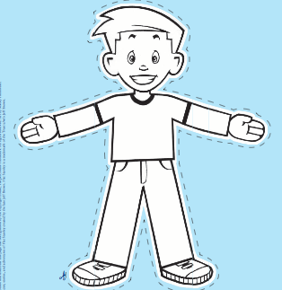
Flat “Scientist” Stanley
Part 1: Sending Stanley into the Real World

Note: You do not have to complete both parts 1 and 2, if you do not wish OR if part 1 is not returned

Across the world, many individuals are engaged in the application of real world science, on a daily basis. Flat “Scientist” Stanley will have the opportunity to share his adventures with all of the students at Patapsco Middle School. Through this experience, students have the chance to explore many career opportunities in an array of fields of science. All students are exposed to many fascinating fields and gain a deeper understanding the interconnectedness with science.

Within this task students must complete the following:
- Select a profession, related to our content, and research contact information Be sure to select a career that is of interest to you! Research and find something that is appealing to you!
- Determine the contact information for the Educational Outreach Contact.
- Develop a letter, explaining the following:
  - Purpose of the assignment (no, not just for homework! Remember why are you interested in know more about this career)
  - What you would like for the scientist to do with flat Stanley, while visiting For example:
    - What do they do all day?
    - How is science integrated into their career?
    - What would happen if their career no longer existed?
    - Why is their career important to society?
    - Or any other question you can think of!
- Create an image of Flat “Scientist” Stanley that reflects what you think the scientist would wear
- Have your letter & Stanley approved by a parent
- Submit letter and Stanley for approval from Mrs. Stephenson
- Be sure to:
  - Follow appropriate letter writing criterion with limited grammatical errors
  - Have the return address as the school (8885 Old Frederick Road. Ellicott City, MD 21043 Attn: Mrs. Danielle Stephenson)

